Just like TMS you would be able to add as many search by options as needed
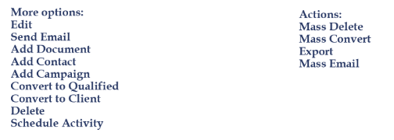
Add Prospect, Import Prospect, Actions and the More menu would all be permission based
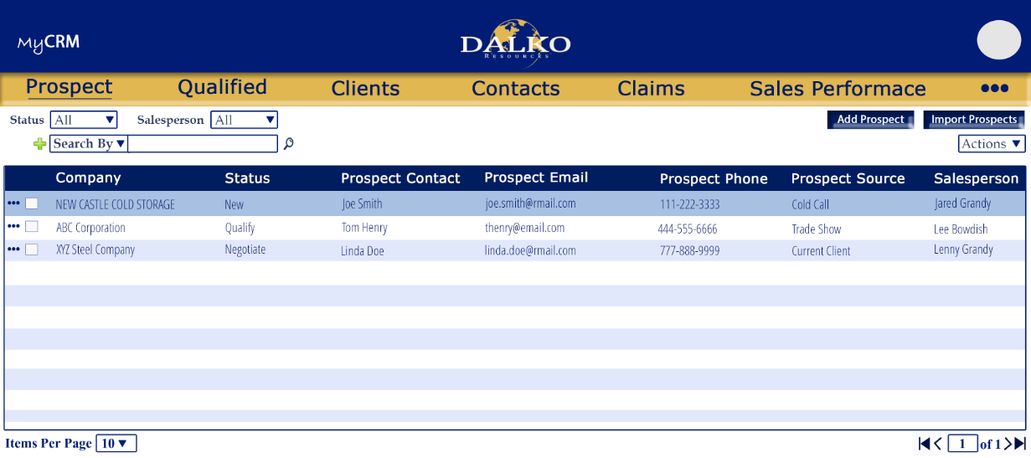

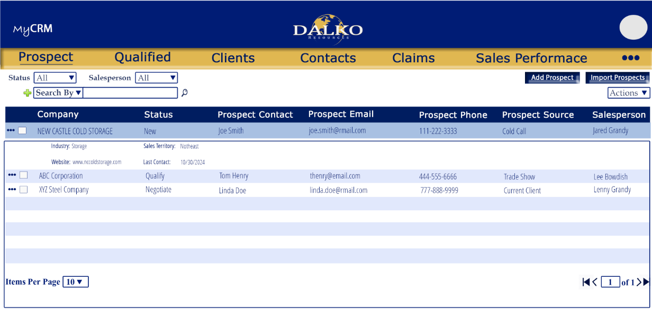

New/Edit
Unlike the current CRM you would not have to click to edit each field. Instead all fields would be open to edit, we would add a Save button and the button would be permission based. That would allow certain users to view details but not save the changes.

If a contact is added in this screen is will also be added to the Contacts screen and vice versa
If a Activity is added in this screen is will also be added to the Activities screen and vice versa (if we have one)
If a campaign is added in this screen is will also be added to the Campaigns screen and vice versa
If a contact log is added under the Contact it will also be added under Contact log on this screen and vice versa

Activities More menu Options:


